2253 CFGS Web Application Development

Module 2 – Data Bases

UF2 – SQL Language: DDL and DML
NF4 – Data Manipulation Language
ACTIVITY

ACTIVITY DONE BY  Aaron Andal | 1DAW

Activity 3.3: Data Manipulation Language

Description

1. Implement next SQL DML statements in HOSPITAL database.

The Entity-Relationship:

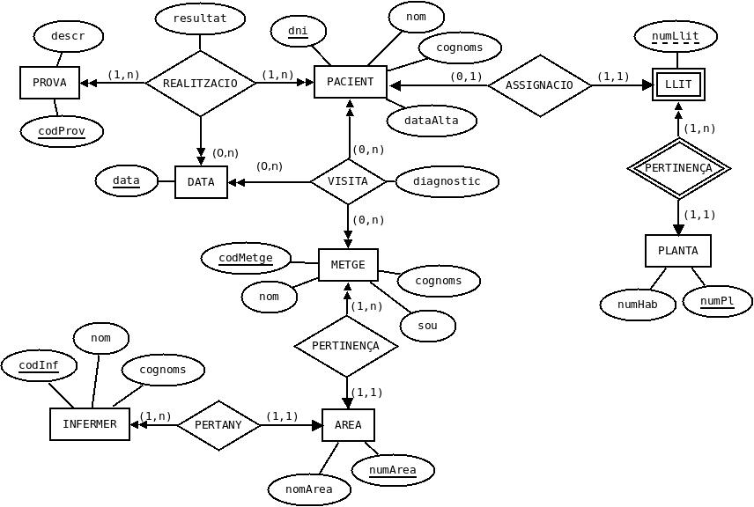
And the relational model:

AREA (numArea, nomArea)

PROVA (codProv, descr)

PLANTA (numPl, numHab)

LLIT (numPl, numLlit)
ON {numPl} REFERENCIA PLANTA

PACIENT (dni, nom, cognoms, dataAlta, numP, numL)
ON {numP,numL} REFERENCIA LLIT (numPl,numLlit)

METGE (codMetge, nom, cognoms, sou, numArea)
ON {numArea} REFERENCIA AREA

INFERMER (codInf, nom, cognoms, numArea)
ON {numArea} REFERENCIA AREA

VISITA (dniPac, codMetge, data, diagnostic)
ON {dniPac} REFERENCIA PACIENT(dni)
i {codMetge} REFERENCIA METGE

REALITZACIO (codProv, dniPac, data, resultat)
ON {codProv} REFERENCIA PROVA
i {dniPac} REFERENCIA PACIENT(dni)

- Select all the doctors with the information of the areas where they belong to. Write two sentences.

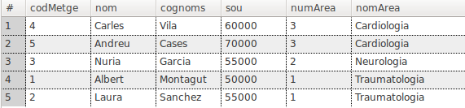
SELECT * FROM METGE NATURAL JOIN AREA;
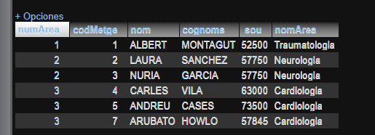

- Select the visits made by the doctor Carles Vila adding tha name and surname of the patient and ordered firstly by the patient surname and secondly by the patient name. Write two sentences.

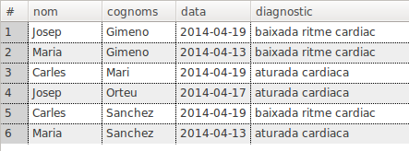
SELECT PACIENT.nom, PACIENT.cognoms, VISITA.data, VISITA.diagnostic FROM PACIENT JOIN VISITA ON (PACIENT.dni = VISITA.dniPac) WHERE VISITA.codMetge = (SELECT METGE.codMetge FROM METGE WHERE METGE.nom = 'Carles' AND METGE.cognoms = 'Vila');

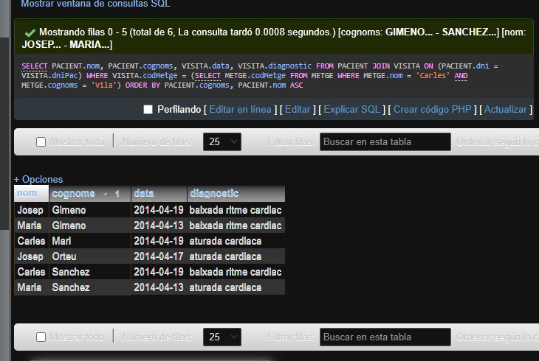

- Select the date and test result of all the tests made to the patient Nuria Mir. Write two sentences.

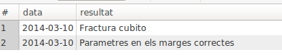
SELECT REALITZACIO.data, REALITZACIO.resultat FROM REALITZACIO JOIN PACIENT ON (REALITZACIO.dniPac = PACIENT.dni) WHERE PACIENT.nom = 'Nuria' AND PACIENT.cognoms = 'Mir';
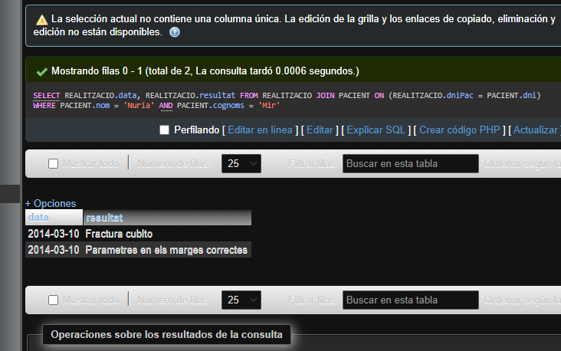

- Select the doctors who has visited the patient Nuria Mir.

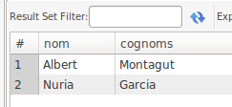
SELECT METGE.nom, METGE.cognoms FROM METGE JOIN VISITA ON (METGE.codMetge = VISITA.codMetge) JOIN PACIENT ON (VISITA.dniPac = PACIENT.dni) WHERE PACIENT.nom = 'Nuria' AND PACIENT.cognoms = 'Mir';
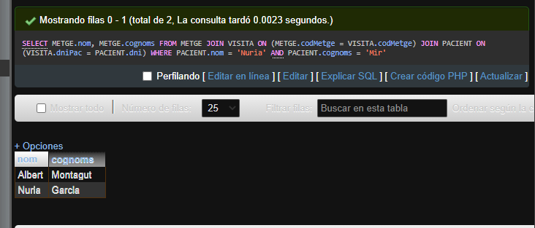

- Select the doctors with the information of the area where they belong to. The list must show all the doctors. There are doctors with no area assigned. Write two sentences.

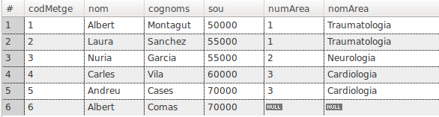
SELECT METGE.codMetge, METGE.nom, METGE.cognoms, METGE.sou, METGE.numArea, AREA.nomArea FROM METGE JOIN AREA ON (METGE.numArea = AREA.numArea);
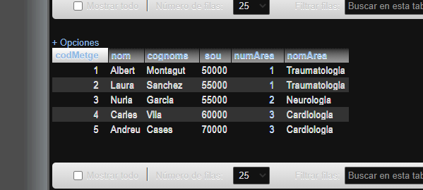

- Select all the employees of the hospital (doctors and nursers).

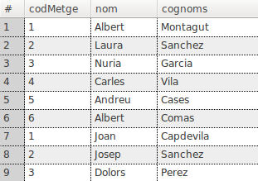

SELECT * FROM METGE JOIN INFERMER ON (METGE.numArea = INFERMER.numAREA);
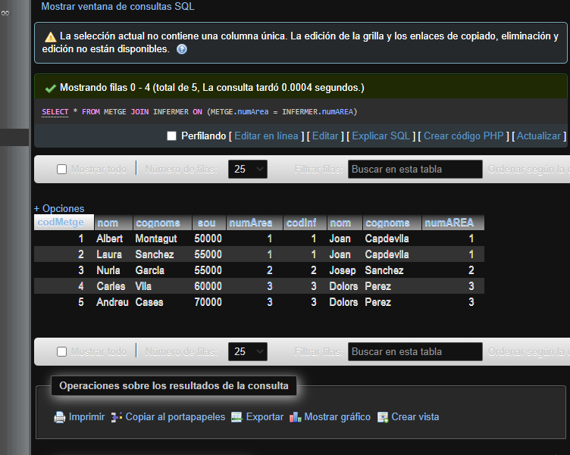

- Select the patients who have not made any test. Write two sentences.

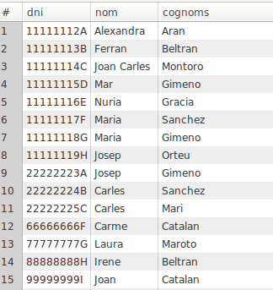

- Select the patients who have not been visited by the doctor Carles Vila. Write two sentences.

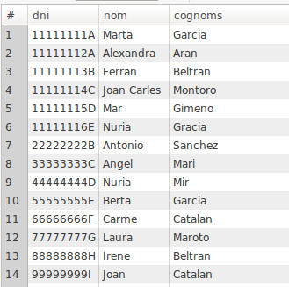

SELECT PACIENT.dni, PACIENT.nom, PACIENT.cognoms FROM PACIENT JOIN VISITA ON (PACIENT.dni = VISITA.dniPac) JOIN METGE ON (VISITA.codMetge = METGE.codMetge) WHERE NOT METGE.nom = 'Carles' AND METGE.cognoms = 'Vila';

- Select the number of doctors who work in every area order by the column numArea.

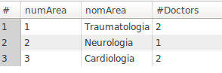

- Select the number of doctors who work in Traumatologia.

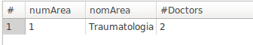

- Select the areas where there are doctors and nurses working ordered by numArea. Write two sentences.

